Ankita Durgude

SQL Exercise 2

1. **Display the Supplier table in the descending order of CITY. Ans:** select * from supplier order by CITY desc;

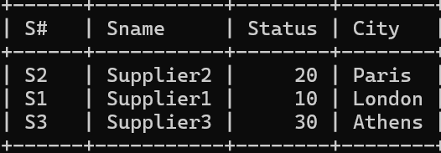

1. **Display the Part Table in the ascending order of CITY and within the city in the ascending order of Part names.**

**Ans:** select * from Parts order by city asc,pname asc;

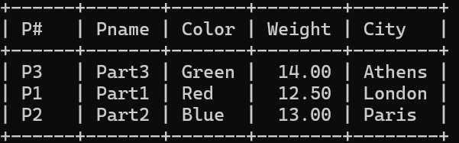

1. **Display all the Suppliers with a status between 10 and 20. Ans:** select * from supplier where status >10 and status<20;

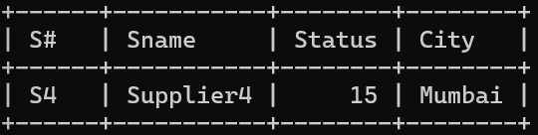

1. **Display all the Parts and their Weight, which are not in the range of 10 and 15. Ans:** select Pname,Weight from Parts where Weight not between 10 and 15;

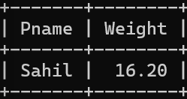

1. **Display all the Part names starting with the letter ‘S’. Ans:** Select * from parts where Pname like 'S%';

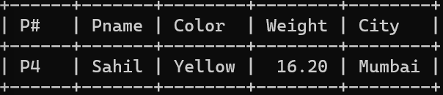

1. **Display all the Suppliers, belonging to cities starting with the letter ‘L’. Ans:** select * from Supplier where city like 'L%';

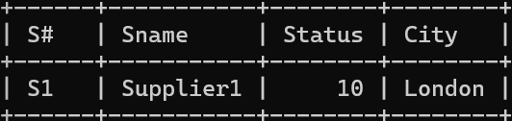

1. **Display all the Projects, with the third letter in JNAME as ‘n’. Ans:** Select * from Projects where JNAME like ' n%';

